LAB 4: TO IMPLEMENT RIPPLE CARRY ADDER

Name: Shreyas Sawant Div: D7A Roll No.: 55

Ripple Carry Adder:

Initial:

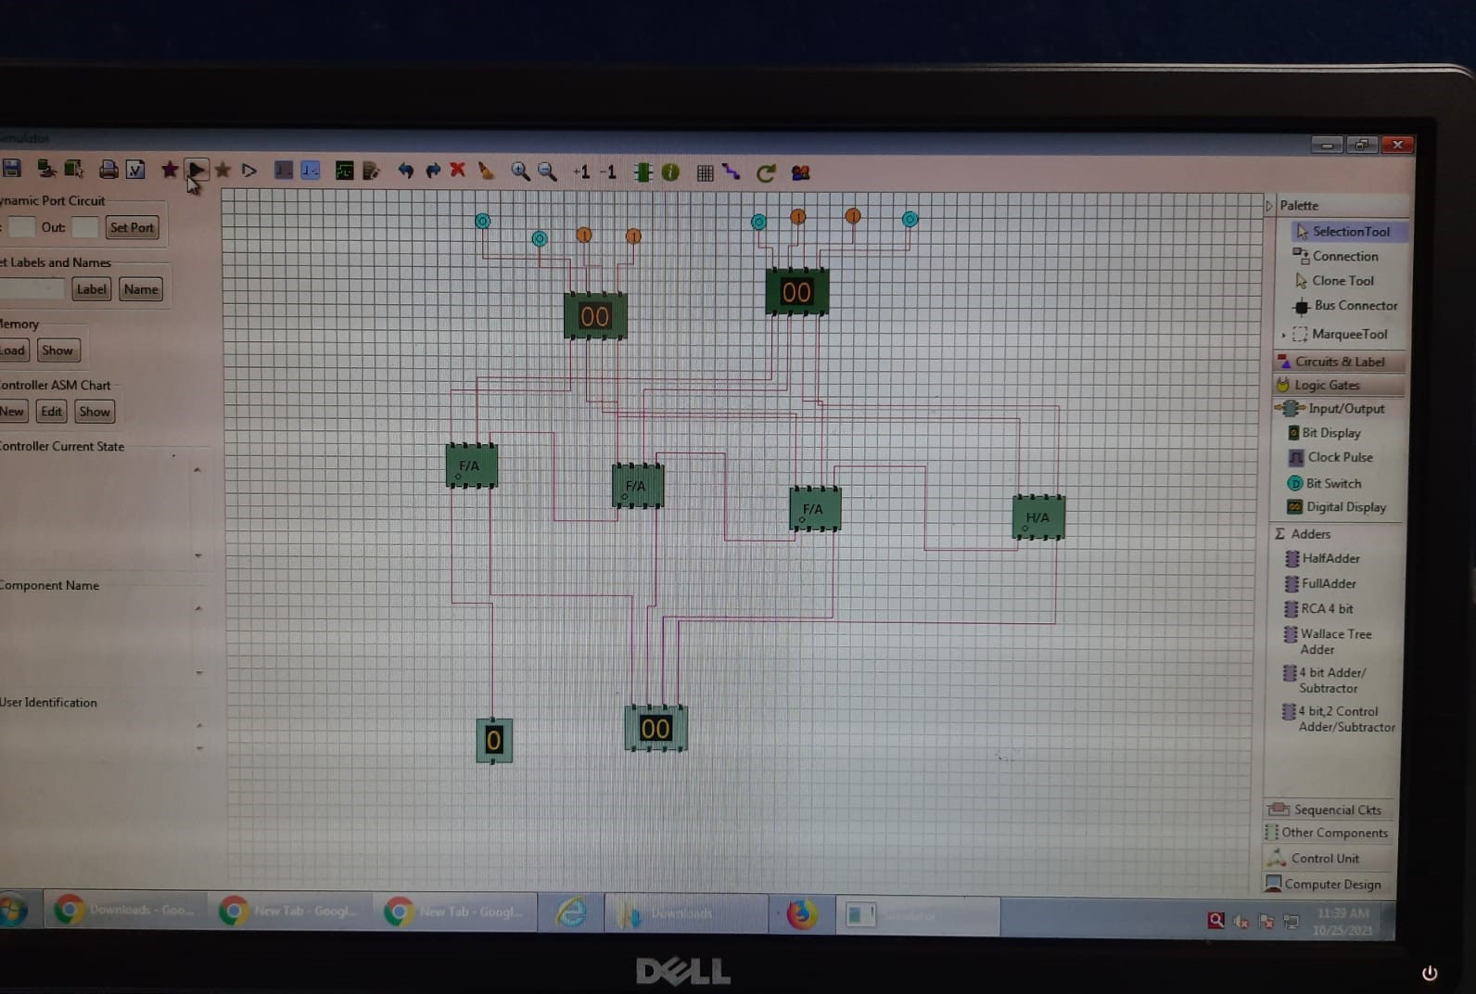

Output: 14+7=21 Carry =1 Sum=5